**事件-表单事件**

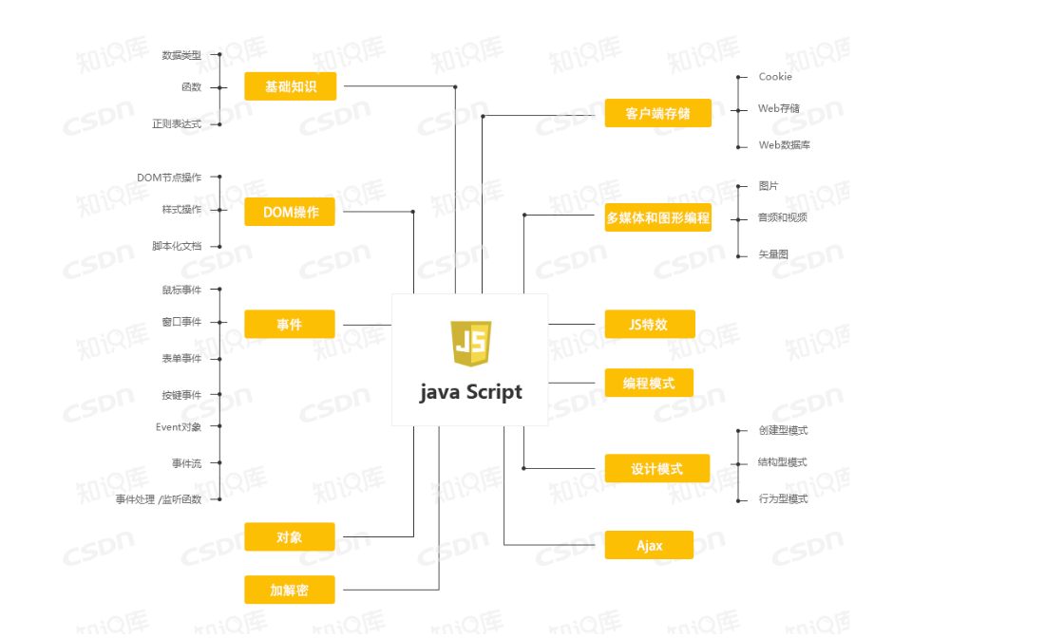

Notice:

form.elements[] property:

The elements[] property is a collection of all the input controls within a form. This is another array

with items listed in the order their HTML tags appear in the source code. It is generally more efficient

to refer to a single element directly using its ID, but sometimes a script needs to look through all of the elements in a form. Especially for form.elements[] property at work in a for repeat loop

**Form Controls as Objects:**

Three kinds of HTML elements nested inside a <form> tag become scriptable objects in all browser

DOMs. Most of the objects owe their existence to the <input> tag in the page’s source code. Only

the value assigned to the type attribute of an <input> tag determines whether the element is a text

box, password entry field, hidden field, button, checkbox, or radio button. The other two kinds of

form controls**, textarea and sel**ect, have their own tags.

1. **Text-related input objects:**

Each of the four text-related HTML form elements — input elements of the text, password,

and hidden types, plus the textarea element — is an element in the document object

hierarchy. We strongly recommend assigning both unique IDs and names to every text-related form control element

When a form is actually submitted to a server-side program, it is the control elements’ name attributes

that are sent to the server along with the elements’ values.

Most of your text-field actions are triggered by the change of text (the

onchange event handler).

Without a doubt, the single most-used property of a text-related element is the value property. This

property represents the current contents of the text element.

1. **The button input object**

We use the button-type input element in many examples in this book. The button is one of the simplest

objects to script. In the simplified object model of this tutorial, the button object has only a few

properties that are rarely accessed or modified in day-to-day scripts

By far the most useful event of the button object is the click event. It fires

whenever the user clicks the button. Simple enough. No magic here

1. **The checkbox input object**

A checkbox is also a simple element of the form object, but some of the properties may not be

entirely intuitive.

<input type="checkbox" id="memory" name="remember-me" value="yup">

<label for="memory">Remember me on this computer</label>

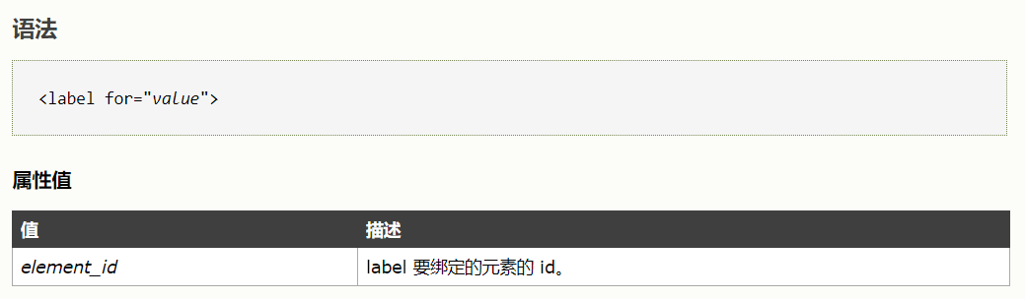

1. **The radio input object**

To let the browser manage the highlighting and unhighlighting of a related group of buttons, you must assign the same name attribute to each of the buttons in the group You can have multiple radio groups within a form, but each member of the same group must have the same name.

Assigning the same name to a form element forces the browser to manage the elements differently

than if they each had a unique name. Instead, the browser maintains an array list of objects with the

same name. The name assigned to the group becomes the name of the array. Some properties apply

to the group as a whole; other properties apply to individual buttons within the group and must be

addressed via array index references.

*formObject*.*groupName*.length

If you want to find out whether a particular button is currently highlighted via the same checked

property used for the checkbox, you can access the button element by its position in the collection of

same-named input fields:

*formObject*.*groupName*[0].checked

**The select object**

The most complex form control to script is the select element object.

The most important property of the select object itself is the selectedIndex property, accessed as

follows:

*formObject*.*selectName*.selectedIndex

This value is the index number of the currently selected item. As with most index counting schemes

in JavaScript, the first item (the one at the top of the list) has an index of zero. The selectedIndex

value is critical for enabling you to access properties of the selected option. Two important properties

of an option item are text and value, accessed as follows:

*formObject.selectName*.options[*n*].text

*formObject*.*selectName*.options[*n*].value

**Passing Elements to Functions with this:**

JavaScript features a keyword — this — that always refers to whatever object contains the script in

which the keyword is used.

if you attach a function to a button by its click event, then

you click the button, the keyword this inside the function refers to the button itself

Using this is

cool: it means having to use fewer global variables, lessening the chance that two independent scripts

will someday use the same global variable name and mess up each other’s logic, and it means that you

can use the same generic function for multiple elements. Here’s a simple example:

function identify()

{

if (this.tagName)

{

alert(’My tagName is ‘ + this.tagName);

}

}

**Submitting and Prevalidating Forms**

we submit a form by clicking on a submit button; the browser then

gathers up the values we entered or selected with the input controls and sends them to the specified

URI. JavaScript lets us intercept that submit request, validate the input or do whatever else we need to

do, and then either permit the form submission to proceed or cancel it so that we can guide the user

to improve the input

You can perform this sort of last-second validation of data or other scripting (for example,

changing the form’s action property based on user choices) in a function invoked by the

form’s onsubmit event handler.

Compare this to how the script in Listing 11-7 cancels the submit event:

function checkForm(evt)

{

// consolidate event handling

if (!evt) evt = window.event;

...

// cancel form submission

// W3C DOM method (hide from IE)

if (evt.preventDefault) evt.preventDefault();

// IE method

return false;

...

}

For browsers compatible with the W3C DOM, the event is added with addEventListener(), and

the form submission is cancelled with preventDefault(). Attempting to invoke a DOM method

that the browser thinks doesn’t exist causes a runtime error, so we protect the older and less capable

browsers by testing first, to make sure the method exists for the event object.

For those less capable browsers, notably Internet Explorer, the event is added to the object by setting

the event property (in this case, onsubmit), and form submission is cancelled simply by returning a

false value from the function called by the event handler.

**Two Method to reference the form elements:**

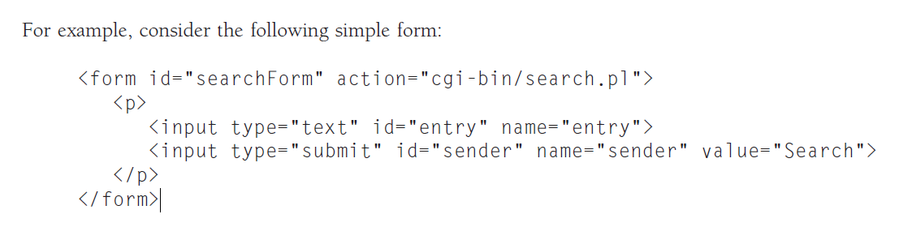

1. DOM Level 2 tree method:

Examples:

* document.getElementById("entry");

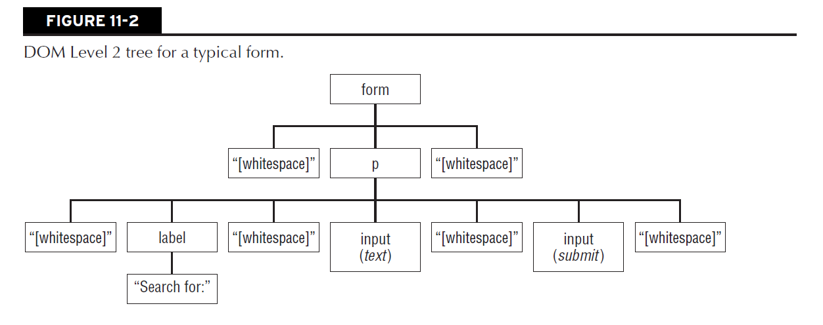

1. DOM level 0 tree method:

Example:

* document.searchForm.entry
* document.searchForm.elements[0]
* document.forms["searchForm"].elements["entry"]
* document.forms["searchForm"].entry

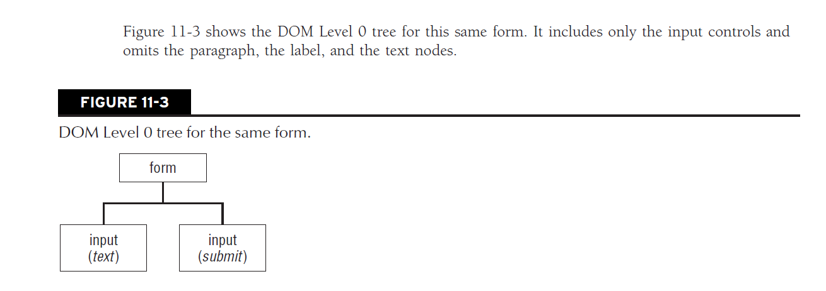



**表单元素引用-**













































